Create Conflict Scenario

ZANSKAR LAND OF GLACIERS AND LAKES OF LADAKH

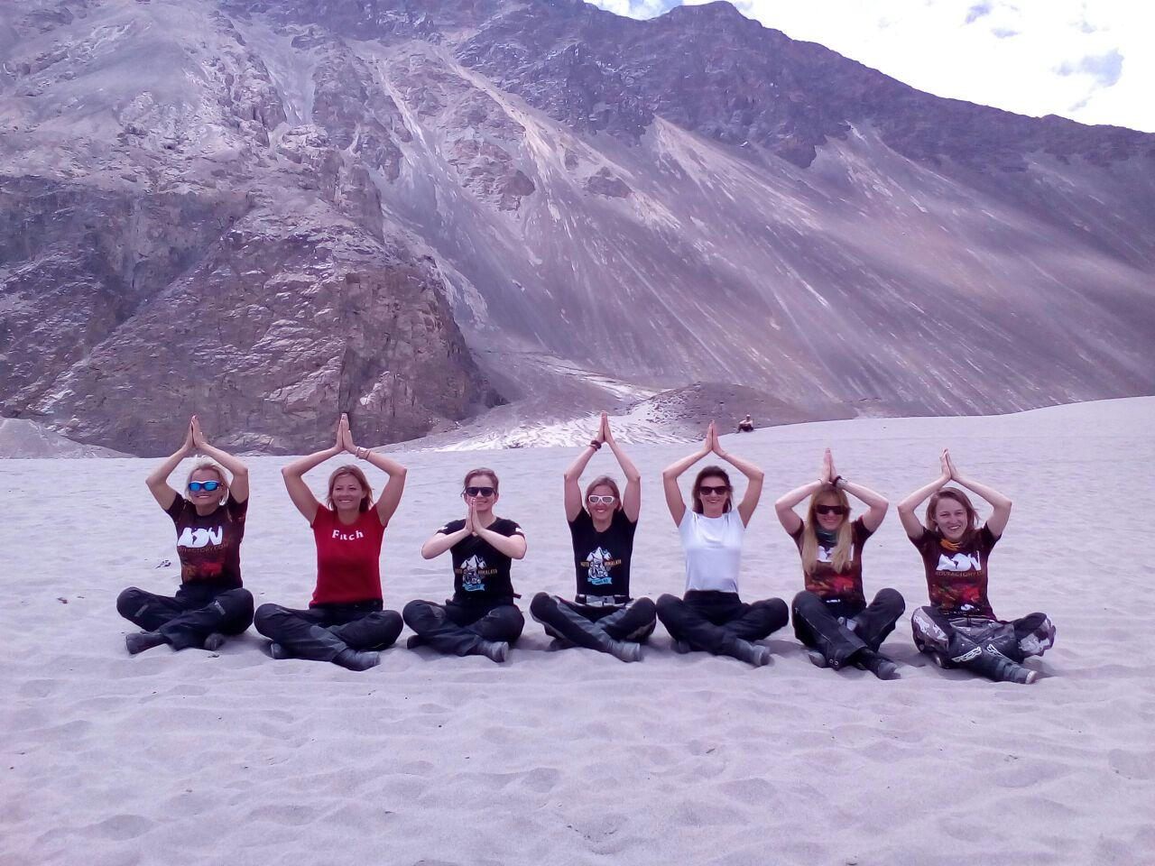

Our Zanskar Bike Tour is founded on our years of experience with motorcycle expeditions in Ladakh. You will experience new tracks, passes and highlights. Extreme Zanskar is very rarely covered and we are delighted to offer you extreme Zanskar bike tour. The off-roading to Ladakh, India’s coldest desert is a once-in-a-life time experience. Staying in tents, eating packed food and enjoying the surrounding environment can only be done in the region like Ladakh. This challenging tour demands solid riding skills, a sense of adventure and flexibility, which is very must require when taking part in Himalaya expeditions which covers around 2800 km and considerable altitude differences.

No of Trip Days | 15 days and 15 nights
Total Distance Covered | 2800km
Off-Roading Distance | 1800km
Best Time to visit | May to September
Staple Food | Dal, Rajma, Rice, Yak meat, Thupka, Momos,Noodles, Maggi,Yak cheese
Culture | Buddhism and Muslim
Number of Passes covered | 15 passes
Number of lakes covered | 5 lakes
Modes of Accessibility | Bike, Jeeps, XUV’s, Cycle, Trekking
Average Temperature | Day time : Average 25 degree Celsius  Night time : Average 5 to 10 degree Celsius
Hotel Stays | 10 days
Tent Stays | 5 days
Average Journey Hours per day | 6 to 8 Hrs.
Highlighted attraction of the Trip | Khardungla Pass, Zozila pass, Penzila, Changlangla, Pangong Lake, Drang-Drum Glacier, Tso Morari lake, White Dessert (Nubra Valley) , Gata Loops and many more. For Details refer Itinerary.

Itinerary
Day 1: - Chandigarh to Patnitop, 450 Km
Road type: Tar Roads and Highways.
Attraction: Hill station in Jammu Kashmir situated on Shivalik belt of Himalaya.
Altitude: 2024m.
Stay: Nice Hotel in a cool weather of Patnitop.
Food: Punjabi Food in a Hotel
Staple Food | Dal, Rajma, Rice, Yak meat, Thupka, Momos,Noodles, Maggi,Yak cheese
Culture | Buddhism and Muslim
Number of Passes covered | 15 passes
Number of lakes covered | 5 lakes
Modes of Accessibility | Bike, Jeeps, XUV’s, Cycle, Trekking
Average Temperature | Day time : Average 25 degree Celsius  Night time : Average 5 to 10 degree Celsius
Hotel Stays | 10 days
Tent Stays | 5 days
Average Journey Hours per day | 6 to 8 Hrs.
Highlighted attraction of the Trip | Khardungla Pass, Zozila pass, Penzila, Changlangla, Pangong Lake, Drang-Drum Glacier, Tso Morari lake, White Dessert (Nubra Valley) , Gata Loops and many more. For Details refer Itinerary.
Staple Food | Dal, Rajma, Rice, Yak meat, Thupka, Momos,Noodles, Maggi,Yak cheese
Culture | Buddhism and Muslim
Number of Passes covered | 15 passes
Number of lakes covered | 5 lakes
Modes of Accessibility | Bike, Jeeps, XUV’s, Cycle, Trekking
Average Temperature | Day time : Average 25 degree Celsius  Night time : Average 5 to 10 degree Celsius
Hotel Stays | 10 days
Tent Stays | 5 days
Average Journey Hours per day | 6 to 8 Hrs.
Highlighted attraction of the Trip | Khardungla Pass, Zozila pass, Penzila, Changlangla, Pangong Lake, Drang-Drum Glacier, Tso Morari lake, White Dessert (Nubra Valley) , Gata Loops and many more. For Details refer Itinerary.

Itinerary
Day 1: - Chandigarh to Patnitop, 450 Km
Road type: Tar Roads and Highways.
Attraction: Hill station in Jammu Kashmir situated on Shivalik belt of Himalaya.
Altitude: 2024m.
Stay: Nice Hotel in a cool weather of Patnitop.
Food: Punjabi Food in a Hotel

Itinerary
Day 1: - Chandigarh to Patnitop, 450 Km
Road type: Tar Roads and Highways.
Attraction: Hill station in Jammu Kashmir situated on Shivalik belt of Himalaya.
Altitude: 2024m.
Stay: Nice Hotel in a cool weather of Patnitop.
Food: Punjabi Food in a Hotel

Staple Food | Dal, Rajma, Rice, Yak meat, Thupka, Momos,Noodles, Maggi,Yak cheese
Culture | Buddhism and Muslim
Number of Passes covered | 15 passes
Number of lakes covered | 5 lakes
Modes of Accessibility | Bike, Jeeps, XUV’s, Cycle, Trekking
Average Temperature | Day time : Average 25 degree Celsius  Night time : Average 5 to 10 degree Celsius
Hotel Stays | 10 days
Tent Stays | 5 days
Average Journey Hours per day | 6 to 8 Hrs.
Highlighted attraction of the Trip | Khardungla Pass, Zozila pass, Penzila, Changlangla, Pangong Lake, Drang-Drum Glacier, Tso Morari lake, White Dessert (Nubra Valley) , Gata Loops and many more. For Details refer Itinerary.

Itinerary
Day 1: - Chandigarh to Patnitop, 450 Km
Road type: Tar Roads and Highways.
Attraction: Hill station in Jammu Kashmir situated on Shivalik belt of Himalaya.
Altitude: 2024m.
Stay: Nice Hotel in a cool weather of Patnitop.
Food: Punjabi Food in a Hotel

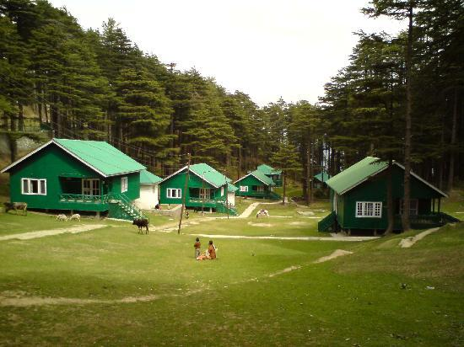
Day 2:- Pinetop to Srinagar, 170Km
Road type: Tar Roads and Highways.
Attraction: Flowing Chenab River along the Road side, Longest Tunnel in India “Jawahar Tunnel”, Dal Lake.
Altitude: 1585m.
Stay: Nice Hotel in Srinagar
Food: Staple Veg /Non Veg Food of Srinagar served on Shakira or Walk Street.

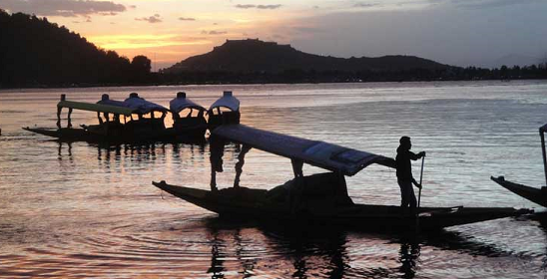

Day 3:- Srinagar to Kargil, 200km
Road type: 50% Off-roading and 50% back-top road.
Attraction: Zozila Pass (4300m), Musical Suru River, Drass (world’s second coldest habitant place, War Memorial.
Altitude: 2600m.
Stay: Nice Hotel in Kargil
Food: Staple Veg/ Non Veg Food Baltistan.
Staple Food | Dal, Rajma, Rice, Yak meat, Thupka, Momos,Noodles, Maggi,Yak cheese
Culture | Buddhism and Muslim
Number of Passes covered | 15 passes
Number of lakes covered | 5 lakes
Modes of Accessibility | Bike, Jeeps, XUV’s, Cycle, Trekking
Average Temperature | Day time : Average 25 degree Celsius  Night time : Average 5 to 10 degree Celsius
Hotel Stays | 10 days
Tent Stays | 5 days
Average Journey Hours per day | 6 to 8 Hrs.
Highlighted attraction of the Trip | Khardungla Pass, Zozila pass, Penzila, Changlangla, Pangong Lake, Drang-Drum Glacier, Tso Morari lake, White Dessert (Nubra Valley) , Gata Loops and many more. For Details refer Itinerary.

Itinerary
Day 1: - Chandigarh to Patnitop, 450 Km
Road type: Tar Roads and Highways.
Attraction: Hill station in Jammu Kashmir situated on Shivalik belt of Himalaya.
Altitude: 2024m.
Stay: Nice Hotel in a cool weather of Patnitop.
Food: Punjabi Food in a Hotel

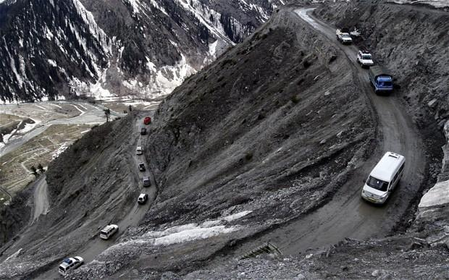

Day 4:-Kargil to Rangdum, 130 Km.
Road type: 90% Off-roading and 10% back-top road.
Attraction: Goosebumps giving view of Galaxy in Rangdum, Suru Valley, Nun-Kun Glacier. Don’t forget to bring Tri-pod, Beautiful Rangdum Monastery
Altitude: 3657m. (12000ft)
Stay: Stay in a tent
Food: Dal, Rice, Curry, Local Juicy Fruit, Cheese Paratha, local rum (if required)

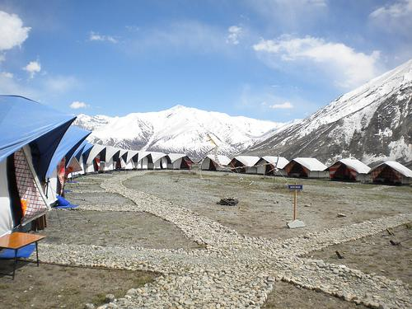
Day 5:- Rangdum to Padum, 90Km.
Road type: 100% Off-roading .
Attraction: Penzila Pass (4401m), Drang-Drum Glacier, Remotest Village Padum.
Altitude: 3669m. (12000ft)
Stay: Stay in a tent
Food: Dal, Rice, Curry, Local Juicy Fruit, Veg Thumpka, Local food .
Staple Food | Dal, Rajma, Rice, Yak meat, Thupka, Momos,Noodles, Maggi,Yak cheese
Culture | Buddhism and Muslim
Number of Passes covered | 15 passes
Number of lakes covered | 5 lakes
Modes of Accessibility | Bike, Jeeps, XUV’s, Cycle, Trekking
Average Temperature | Day time : Average 25 degree Celsius  Night time : Average 5 to 10 degree Celsius
Hotel Stays | 10 days
Tent Stays | 5 days
Average Journey Hours per day | 6 to 8 Hrs.
Highlighted attraction of the Trip | Khardungla Pass, Zozila pass, Penzila, Changlangla, Pangong Lake, Drang-Drum Glacier, Tso Morari lake, White Dessert (Nubra Valley) , Gata Loops and many more. For Details refer Itinerary.

Itinerary
Day 1: - Chandigarh to Patnitop, 450 Km
Road type: Tar Roads and Highways.
Attraction: Hill station in Jammu Kashmir situated on Shivalik belt of Himalaya.
Altitude: 2024m.
Stay: Nice Hotel in a cool weather of Patnitop.
Food: Punjabi Food in a Hotel

Staple Food | Dal, Rajma, Rice, Yak meat, Thupka, Momos,Noodles, Maggi,Yak cheese
Culture | Buddhism and Muslim
Number of Passes covered | 15 passes
Number of lakes covered | 5 lakes
Modes of Accessibility | Bike, Jeeps, XUV’s, Cycle, Trekking
Average Temperature | Day time : Average 25 degree Celsius  Night time : Average 5 to 10 degree Celsius
Hotel Stays | 10 days
Tent Stays | 5 days
Average Journey Hours per day | 6 to 8 Hrs.
Highlighted attraction of the Trip | Khardungla Pass, Zozila pass, Penzila, Changlangla, Pangong Lake, Drang-Drum Glacier, Tso Morari lake, White Dessert (Nubra Valley) , Gata Loops and many more. For Details refer Itinerary.

Itinerary
Day 1: - Chandigarh to Patnitop, 450 Km
Road type: Tar Roads and Highways.
Attraction: Hill station in Jammu Kashmir situated on Shivalik belt of Himalaya.
Altitude: 2024m.
Stay: Nice Hotel in a cool weather of Patnitop.
Food: Punjabi Food in a Hotel

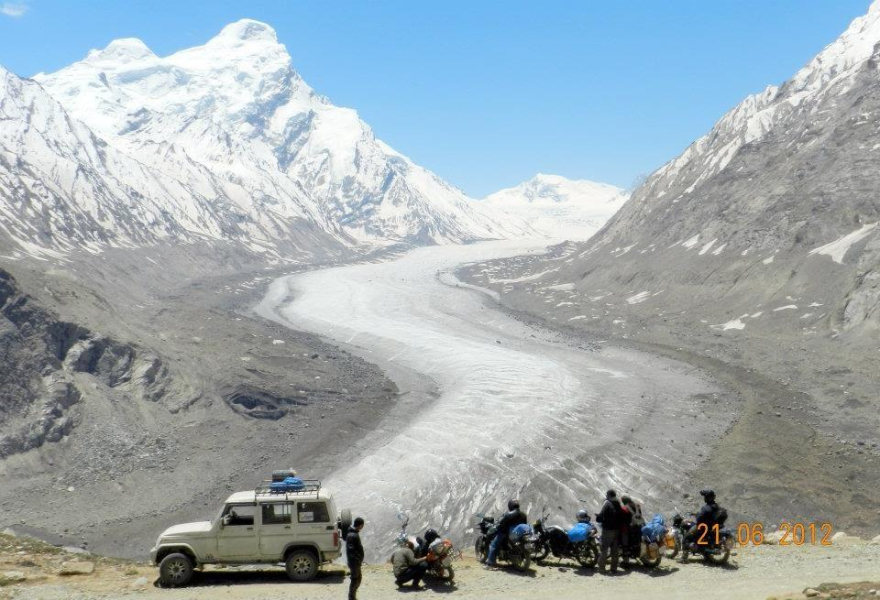

Day 6:- Sightseeing in Padum
Attraction:Karsha Monastery, Sunset View, and Waterfall, Have Chat with Locals.

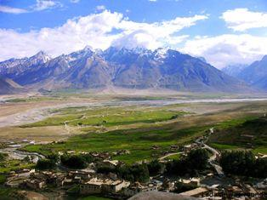

Day 7: – Padum (ZanskarValley) to Parkachik, 180 km
Road type: 100% Off-roading .
Attraction: Penzila Pass (4401m), Drang-Drum Glacier, Nun-Kun Glacier, Yoga Sessions.
Altitude: 3200m
Stay: Stay in a Guest House
Food: Local taste of Dal, Rice, Curry.

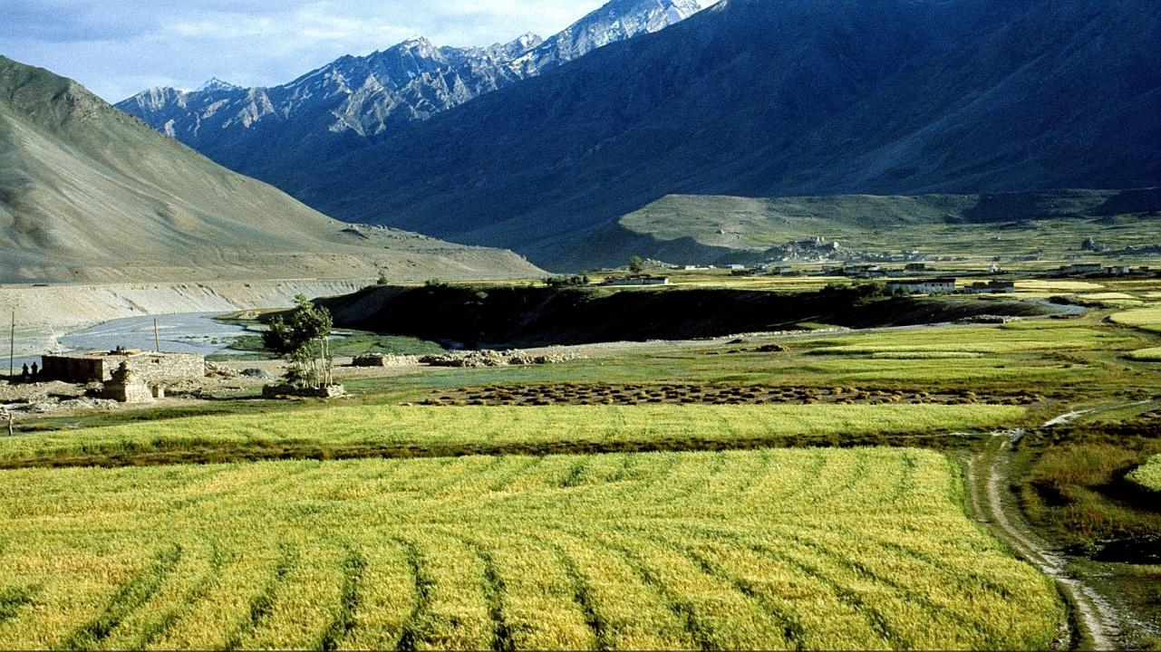

Day 8:- Parkachik to Lamayuru, 190km
Road type: 50% Off-roading and 50% back-top road.
Attraction: Fotula Pass (4108m), Namkila Pass (3978m), Moon like Landscape of Lamayaru, 500 year old monastery, Yoga sessions.
Altitude: 3510m.
Stay: Stay in a Hotel with a moonland view.
Food: Proper 4 course meal.
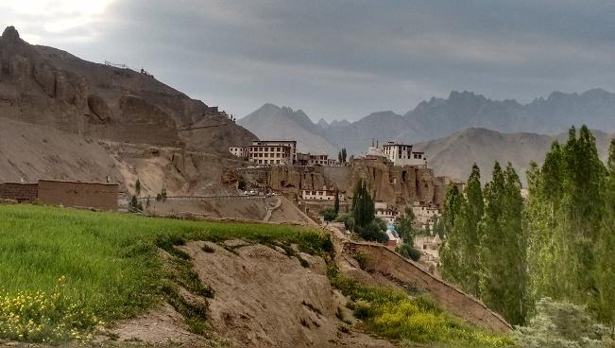

Day 9:- Lamayuru to Leh, 140km
Road type: 100% back-top road.
Attraction: Magnetic Hill, PatharsahebGurudwara, Sangam of Indus and Zanskar River
Altitude: 3500m.
Stay: Stay in a Hotel near Leh Bazaar
Food: Proper 4 course meal.

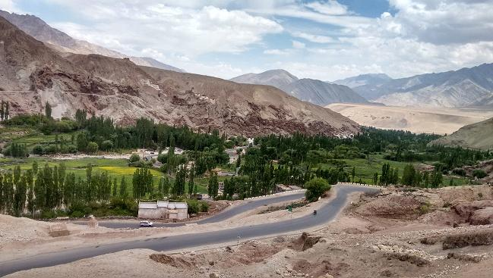
Day 10:-Rest and Local Sightseeing day in Leh
Servicing day for Bikes and local sightseeing day for us. You can enjoy the visit to Shea Palace, Shanti Stupa, Hall of Fame and many more.

Day 11:- Leh to Hunder (Nubra Valley) 150km
Road type: 50% Off-roading and 50% back-top road.
Attraction: The famous KHARDUNGLA Pass(5360m or 18379ft), White Dessert Nubra Valley, Double Hunk Camel Safari, Shyok River.
Altitude: 3048m.
Stay: Stay in a Tent near stream
Food: staple 4 course meal.

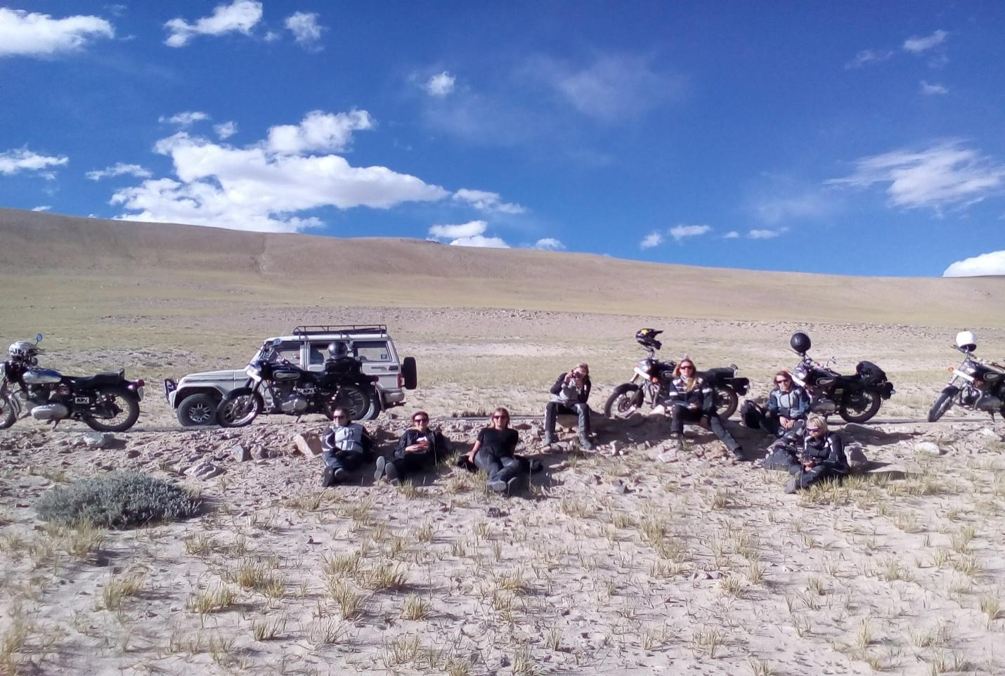

Day 12:- Hunder to Pangong Tso 180km
Road type: 100% Off-roading
Attraction: Chang-La Pass (5359m), Luminous Blue-Green Pangong Lake (5360m).
Altitude: 5360m.
Stay: Stay in a Tents
Food: staple food
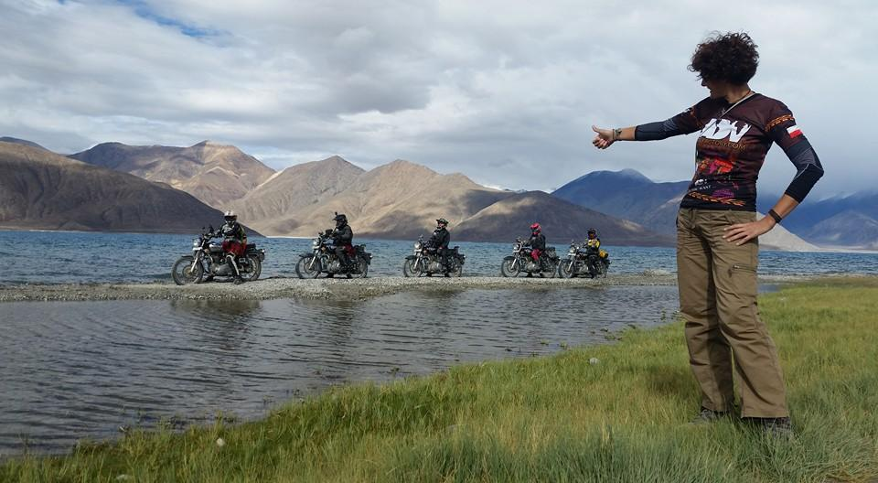

Day 13:-PangongTso to Tso Morari 210 km
Road type: 100% Off-roading
Attraction: Nakeela Pass (4769m), Tanglang la Pass (5328m), Tso Kar Lake, Magnificent Tso Morari Lake
Altitude: 4595m.
Stay: Stay in a Tents
Food: staple food
Staple Food | Dal, Rajma, Rice, Yak meat, Thupka, Momos,Noodles, Maggi,Yak cheese
Culture | Buddhism and Muslim
Number of Passes covered | 15 passes
Number of lakes covered | 5 lakes
Modes of Accessibility | Bike, Jeeps, XUV’s, Cycle, Trekking
Average Temperature | Day time : Average 25 degree Celsius  Night time : Average 5 to 10 degree Celsius
Hotel Stays | 10 days
Tent Stays | 5 days
Average Journey Hours per day | 6 to 8 Hrs.
Highlighted attraction of the Trip | Khardungla Pass, Zozila pass, Penzila, Changlangla, Pangong Lake, Drang-Drum Glacier, Tso Morari lake, White Dessert (Nubra Valley) , Gata Loops and many more. For Details refer Itinerary.

Itinerary
Day 1: - Chandigarh to Patnitop, 450 Km
Road type: Tar Roads and Highways.
Attraction: Hill station in Jammu Kashmir situated on Shivalik belt of Himalaya.
Altitude: 2024m.
Stay: Nice Hotel in a cool weather of Patnitop.
Food: Punjabi Food in a Hotel

Staple Food | Dal, Rajma, Rice, Yak meat, Thupka, Momos,Noodles, Maggi,Yak cheese
Culture | Buddhism and Muslim
Number of Passes covered | 15 passes
Number of lakes covered | 5 lakes
Modes of Accessibility | Bike, Jeeps, XUV’s, Cycle, Trekking
Average Temperature | Day time : Average 25 degree Celsius  Night time : Average 5 to 10 degree Celsius
Hotel Stays | 10 days
Tent Stays | 5 days
Average Journey Hours per day | 6 to 8 Hrs.
Highlighted attraction of the Trip | Khardungla Pass, Zozila pass, Penzila, Changlangla, Pangong Lake, Drang-Drum Glacier, Tso Morari lake, White Dessert (Nubra Valley) , Gata Loops and many more. For Details refer Itinerary.

Itinerary
Day 1: - Chandigarh to Patnitop, 450 Km
Road type: Tar Roads and Highways.
Attraction: Hill station in Jammu Kashmir situated on Shivalik belt of Himalaya.
Altitude: 2024m.
Stay: Nice Hotel in a cool weather of Patnitop.
Food: Punjabi Food in a Hotel

Staple Food | Dal, Rajma, Rice, Yak meat, Thupka, Momos,Noodles, Maggi,Yak cheese
Culture | Buddhism and Muslim
Number of Passes covered | 15 passes
Number of lakes covered | 5 lakes
Modes of Accessibility | Bike, Jeeps, XUV’s, Cycle, Trekking
Average Temperature | Day time : Average 25 degree Celsius  Night time : Average 5 to 10 degree Celsius
Hotel Stays | 10 days
Tent Stays | 5 days
Average Journey Hours per day | 6 to 8 Hrs.
Highlighted attraction of the Trip | Khardungla Pass, Zozila pass, Penzila, Changlangla, Pangong Lake, Drang-Drum Glacier, Tso Morari lake, White Dessert (Nubra Valley) , Gata Loops and many more. For Details refer Itinerary.

Itinerary
Day 1: - Chandigarh to Patnitop, 450 Km
Road type: Tar Roads and Highways.
Attraction: Hill station in Jammu Kashmir situated on Shivalik belt of Himalaya.
Altitude: 2024m.
Stay: Nice Hotel in a cool weather of Patnitop.
Food: Punjabi Food in a Hotel

Staple Food | Dal, Rajma, Rice, Yak meat, Thupka, Momos,Noodles, Maggi,Yak cheese
Culture | Buddhism and Muslim
Number of Passes covered | 15 passes
Number of lakes covered | 5 lakes
Modes of Accessibility | Bike, Jeeps, XUV’s, Cycle, Trekking
Average Temperature | Day time : Average 25 degree Celsius  Night time : Average 5 to 10 degree Celsius
Hotel Stays | 10 days
Tent Stays | 5 days
Average Journey Hours per day | 6 to 8 Hrs.
Highlighted attraction of the Trip | Khardungla Pass, Zozila pass, Penzila, Changlangla, Pangong Lake, Drang-Drum Glacier, Tso Morari lake, White Dessert (Nubra Valley) , Gata Loops and many more. For Details refer Itinerary.

Itinerary
Day 1: - Chandigarh to Patnitop, 450 Km
Road type: Tar Roads and Highways.
Attraction: Hill station in Jammu Kashmir situated on Shivalik belt of Himalaya.
Altitude: 2024m.
Stay: Nice Hotel in a cool weather of Patnitop.
Food: Punjabi Food in a Hotel

Staple Food | Dal, Rajma, Rice, Yak meat, Thupka, Momos,Noodles, Maggi,Yak cheese
Culture | Buddhism and Muslim
Number of Passes covered | 15 passes
Number of lakes covered | 5 lakes
Modes of Accessibility | Bike, Jeeps, XUV’s, Cycle, Trekking
Average Temperature | Day time : Average 25 degree Celsius  Night time : Average 5 to 10 degree Celsius
Hotel Stays | 10 days
Tent Stays | 5 days
Average Journey Hours per day | 6 to 8 Hrs.
Highlighted attraction of the Trip | Khardungla Pass, Zozila pass, Penzila, Changlangla, Pangong Lake, Drang-Drum Glacier, Tso Morari lake, White Dessert (Nubra Valley) , Gata Loops and many more. For Details refer Itinerary.

Itinerary
Day 1: - Chandigarh to Patnitop, 450 Km
Road type: Tar Roads and Highways.
Attraction: Hill station in Jammu Kashmir situated on Shivalik belt of Himalaya.
Altitude: 2024m.
Stay: Nice Hotel in a cool weather of Patnitop.
Food: Punjabi Food in a Hotel

Staple Food | Dal, Rajma, Rice, Yak meat, Thupka, Momos,Noodles, Maggi,Yak cheese
Culture | Buddhism and Muslim
Number of Passes covered | 15 passes
Number of lakes covered | 5 lakes
Modes of Accessibility | Bike, Jeeps, XUV’s, Cycle, Trekking
Average Temperature | Day time : Average 25 degree Celsius  Night time : Average 5 to 10 degree Celsius
Hotel Stays | 10 days
Tent Stays | 5 days
Average Journey Hours per day | 6 to 8 Hrs.
Highlighted attraction of the Trip | Khardungla Pass, Zozila pass, Penzila, Changlangla, Pangong Lake, Drang-Drum Glacier, Tso Morari lake, White Dessert (Nubra Valley) , Gata Loops and many more. For Details refer Itinerary.

Itinerary
Day 1: - Chandigarh to Patnitop, 450 Km
Road type: Tar Roads and Highways.
Attraction: Hill station in Jammu Kashmir situated on Shivalik belt of Himalaya.
Altitude: 2024m.
Stay: Nice Hotel in a cool weather of Patnitop.
Food: Punjabi Food in a Hotel

Staple Food | Dal, Rajma, Rice, Yak meat, Thupka, Momos,Noodles, Maggi,Yak cheese
Culture | Buddhism and Muslim
Number of Passes covered | 15 passes
Number of lakes covered | 5 lakes
Modes of Accessibility | Bike, Jeeps, XUV’s, Cycle, Trekking
Average Temperature | Day time : Average 25 degree Celsius  Night time : Average 5 to 10 degree Celsius
Hotel Stays | 10 days
Tent Stays | 5 days
Average Journey Hours per day | 6 to 8 Hrs.
Highlighted attraction of the Trip | Khardungla Pass, Zozila pass, Penzila, Changlangla, Pangong Lake, Drang-Drum Glacier, Tso Morari lake, White Dessert (Nubra Valley) , Gata Loops and many more. For Details refer Itinerary.

Itinerary
Day 1: - Chandigarh to Patnitop, 450 Km
Road type: Tar Roads and Highways.
Attraction: Hill station in Jammu Kashmir situated on Shivalik belt of Himalaya.
Altitude: 2024m.
Stay: Nice Hotel in a cool weather of Patnitop.
Food: Punjabi Food in a Hotel

Staple Food | Dal, Rajma, Rice, Yak meat, Thupka, Momos,Noodles, Maggi,Yak cheese
Culture | Buddhism and Muslim
Number of Passes covered | 15 passes
Number of lakes covered | 5 lakes
Modes of Accessibility | Bike, Jeeps, XUV’s, Cycle, Trekking
Average Temperature | Day time : Average 25 degree Celsius  Night time : Average 5 to 10 degree Celsius
Hotel Stays | 10 days
Tent Stays | 5 days
Average Journey Hours per day | 6 to 8 Hrs.
Highlighted attraction of the Trip | Khardungla Pass, Zozila pass, Penzila, Changlangla, Pangong Lake, Drang-Drum Glacier, Tso Morari lake, White Dessert (Nubra Valley) , Gata Loops and many more. For Details refer Itinerary.

Itinerary
Day 1: - Chandigarh to Patnitop, 450 Km
Road type: Tar Roads and Highways.
Attraction: Hill station in Jammu Kashmir situated on Shivalik belt of Himalaya.
Altitude: 2024m.
Stay: Nice Hotel in a cool weather of Patnitop.
Food: Punjabi Food in a Hotel

Staple Food | Dal, Rajma, Rice, Yak meat, Thupka, Momos,Noodles, Maggi,Yak cheese
Culture | Buddhism and Muslim
Number of Passes covered | 15 passes
Number of lakes covered | 5 lakes
Modes of Accessibility | Bike, Jeeps, XUV’s, Cycle, Trekking
Average Temperature | Day time : Average 25 degree Celsius  Night time : Average 5 to 10 degree Celsius
Hotel Stays | 10 days
Tent Stays | 5 days
Average Journey Hours per day | 6 to 8 Hrs.
Highlighted attraction of the Trip | Khardungla Pass, Zozila pass, Penzila, Changlangla, Pangong Lake, Drang-Drum Glacier, Tso Morari lake, White Dessert (Nubra Valley) , Gata Loops and many more. For Details refer Itinerary.

Itinerary
Day 1: - Chandigarh to Patnitop, 450 Km
Road type: Tar Roads and Highways.
Attraction: Hill station in Jammu Kashmir situated on Shivalik belt of Himalaya.
Altitude: 2024m.
Stay: Nice Hotel in a cool weather of Patnitop.
Food: Punjabi Food in a Hotel

Staple Food | Dal, Rajma, Rice, Yak meat, Thupka, Momos,Noodles, Maggi,Yak cheese
Culture | Buddhism and Muslim
Number of Passes covered | 15 passes
Number of lakes covered | 5 lakes
Modes of Accessibility | Bike, Jeeps, XUV’s, Cycle, Trekking
Average Temperature | Day time : Average 25 degree Celsius  Night time : Average 5 to 10 degree Celsius
Hotel Stays | 10 days
Tent Stays | 5 days
Average Journey Hours per day | 6 to 8 Hrs.
Highlighted attraction of the Trip | Khardungla Pass, Zozila pass, Penzila, Changlangla, Pangong Lake, Drang-Drum Glacier, Tso Morari lake, White Dessert (Nubra Valley) , Gata Loops and many more. For Details refer Itinerary.

Itinerary
Day 1: - Chandigarh to Patnitop, 450 Km
Road type: Tar Roads and Highways.
Attraction: Hill station in Jammu Kashmir situated on Shivalik belt of Himalaya.
Altitude: 2024m.
Stay: Nice Hotel in a cool weather of Patnitop.
Food: Punjabi Food in a Hotel

Staple Food | Dal, Rajma, Rice, Yak meat, Thupka, Momos,Noodles, Maggi,Yak cheese
Culture | Buddhism and Muslim
Number of Passes covered | 15 passes
Number of lakes covered | 5 lakes
Modes of Accessibility | Bike, Jeeps, XUV’s, Cycle, Trekking
Average Temperature | Day time : Average 25 degree Celsius  Night time : Average 5 to 10 degree Celsius
Hotel Stays | 10 days
Tent Stays | 5 days
Average Journey Hours per day | 6 to 8 Hrs.
Highlighted attraction of the Trip | Khardungla Pass, Zozila pass, Penzila, Changlangla, Pangong Lake, Drang-Drum Glacier, Tso Morari lake, White Dessert (Nubra Valley) , Gata Loops and many more. For Details refer Itinerary.

Itinerary
Day 1: - Chandigarh to Patnitop, 450 Km
Road type: Tar Roads and Highways.
Attraction: Hill station in Jammu Kashmir situated on Shivalik belt of Himalaya.
Altitude: 2024m.
Stay: Nice Hotel in a cool weather of Patnitop.
Food: Punjabi Food in a Hotel

Staple Food | Dal, Rajma, Rice, Yak meat, Thupka, Momos,Noodles, Maggi,Yak cheese
Culture | Buddhism and Muslim
Number of Passes covered | 15 passes
Number of lakes covered | 5 lakes
Modes of Accessibility | Bike, Jeeps, XUV’s, Cycle, Trekking
Average Temperature | Day time : Average 25 degree Celsius  Night time : Average 5 to 10 degree Celsius
Hotel Stays | 10 days
Tent Stays | 5 days
Average Journey Hours per day | 6 to 8 Hrs.
Highlighted attraction of the Trip | Khardungla Pass, Zozila pass, Penzila, Changlangla, Pangong Lake, Drang-Drum Glacier, Tso Morari lake, White Dessert (Nubra Valley) , Gata Loops and many more. For Details refer Itinerary.

Itinerary
Day 1: - Chandigarh to Patnitop, 450 Km
Road type: Tar Roads and Highways.
Attraction: Hill station in Jammu Kashmir situated on Shivalik belt of Himalaya.
Altitude: 2024m.
Stay: Nice Hotel in a cool weather of Patnitop.
Food: Punjabi Food in a Hotel

Staple Food | Dal, Rajma, Rice, Yak meat, Thupka, Momos,Noodles, Maggi,Yak cheese
Culture | Buddhism and Muslim
Number of Passes covered | 15 passes
Number of lakes covered | 5 lakes
Modes of Accessibility | Bike, Jeeps, XUV’s, Cycle, Trekking
Average Temperature | Day time : Average 25 degree Celsius  Night time : Average 5 to 10 degree Celsius
Hotel Stays | 10 days
Tent Stays | 5 days
Average Journey Hours per day | 6 to 8 Hrs.
Highlighted attraction of the Trip | Khardungla Pass, Zozila pass, Penzila, Changlangla, Pangong Lake, Drang-Drum Glacier, Tso Morari lake, White Dessert (Nubra Valley) , Gata Loops and many more. For Details refer Itinerary.

Itinerary
Day 1: - Chandigarh to Patnitop, 450 Km
Road type: Tar Roads and Highways.
Attraction: Hill station in Jammu Kashmir situated on Shivalik belt of Himalaya.
Altitude: 2024m.
Stay: Nice Hotel in a cool weather of Patnitop.
Food: Punjabi Food in a Hotel

Staple Food | Dal, Rajma, Rice, Yak meat, Thupka, Momos,Noodles, Maggi,Yak cheese
Culture | Buddhism and Muslim
Number of Passes covered | 15 passes
Number of lakes covered | 5 lakes
Modes of Accessibility | Bike, Jeeps, XUV’s, Cycle, Trekking
Average Temperature | Day time : Average 25 degree Celsius  Night time : Average 5 to 10 degree Celsius
Hotel Stays | 10 days
Tent Stays | 5 days
Average Journey Hours per day | 6 to 8 Hrs.
Highlighted attraction of the Trip | Khardungla Pass, Zozila pass, Penzila, Changlangla, Pangong Lake, Drang-Drum Glacier, Tso Morari lake, White Dessert (Nubra Valley) , Gata Loops and many more. For Details refer Itinerary.

Itinerary
Day 1: - Chandigarh to Patnitop, 450 Km
Road type: Tar Roads and Highways.
Attraction: Hill station in Jammu Kashmir situated on Shivalik belt of Himalaya.
Altitude: 2024m.
Stay: Nice Hotel in a cool weather of Patnitop.
Food: Punjabi Food in a Hotel

Staple Food | Dal, Rajma, Rice, Yak meat, Thupka, Momos,Noodles, Maggi,Yak cheese
Culture | Buddhism and Muslim
Number of Passes covered | 15 passes
Number of lakes covered | 5 lakes
Modes of Accessibility | Bike, Jeeps, XUV’s, Cycle, Trekking
Average Temperature | Day time : Average 25 degree Celsius  Night time : Average 5 to 10 degree Celsius
Hotel Stays | 10 days
Tent Stays | 5 days
Average Journey Hours per day | 6 to 8 Hrs.
Highlighted attraction of the Trip | Khardungla Pass, Zozila pass, Penzila, Changlangla, Pangong Lake, Drang-Drum Glacier, Tso Morari lake, White Dessert (Nubra Valley) , Gata Loops and many more. For Details refer Itinerary.

Itinerary
Day 1: - Chandigarh to Patnitop, 450 Km
Road type: Tar Roads and Highways.
Attraction: Hill station in Jammu Kashmir situated on Shivalik belt of Himalaya.
Altitude: 2024m.
Stay: Nice Hotel in a cool weather of Patnitop.
Food: Punjabi Food in a Hotel

Staple Food | Dal, Rajma, Rice, Yak meat, Thupka, Momos,Noodles, Maggi,Yak cheese
Culture | Buddhism and Muslim
Number of Passes covered | 15 passes
Number of lakes covered | 5 lakes
Modes of Accessibility | Bike, Jeeps, XUV’s, Cycle, Trekking
Average Temperature | Day time : Average 25 degree Celsius  Night time : Average 5 to 10 degree Celsius
Hotel Stays | 10 days
Tent Stays | 5 days
Average Journey Hours per day | 6 to 8 Hrs.
Highlighted attraction of the Trip | Khardungla Pass, Zozila pass, Penzila, Changlangla, Pangong Lake, Drang-Drum Glacier, Tso Morari lake, White Dessert (Nubra Valley) , Gata Loops and many more. For Details refer Itinerary.

Itinerary
Day 1: - Chandigarh to Patnitop, 450 Km
Road type: Tar Roads and Highways.
Attraction: Hill station in Jammu Kashmir situated on Shivalik belt of Himalaya.
Altitude: 2024m.
Stay: Nice Hotel in a cool weather of Patnitop.
Food: Punjabi Food in a Hotel

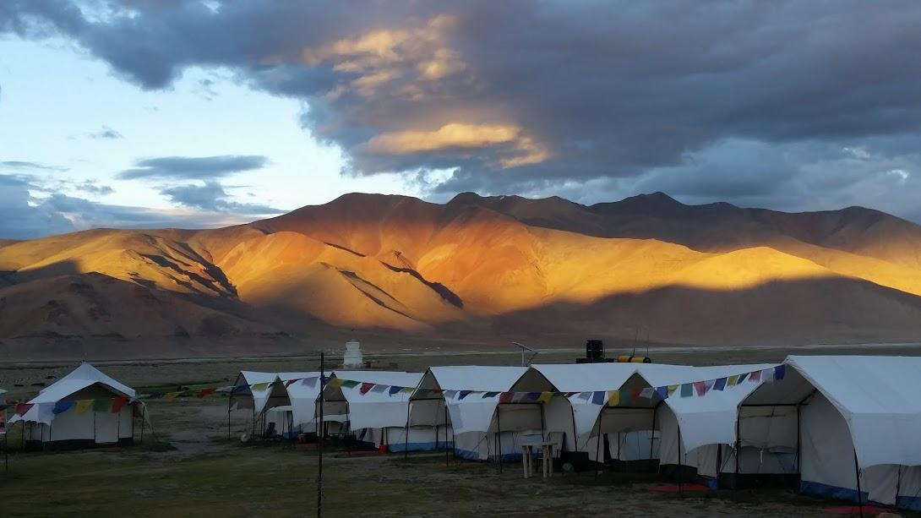

Day 14:- Tso Morari to Sarchu (200 kms)
Road type: 50% Off-roading and 50% back-top road
Attraction: Lachungla Pass (5059m), Namchika la pass, Highest Plateau on earth the Pang.
Altitude: 4290m.
Stay: Stay in Tents
Food: staple food

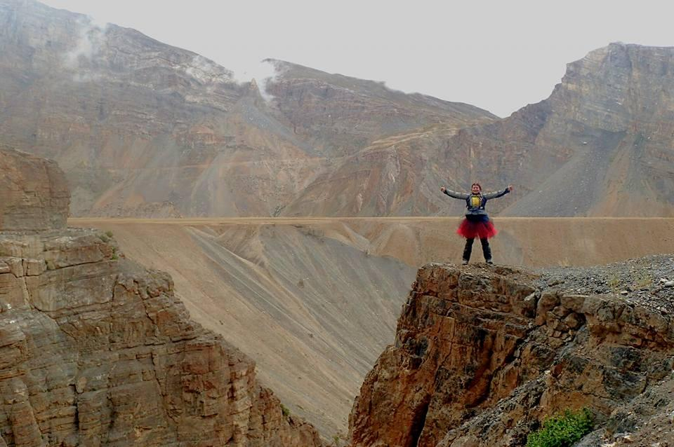

Day 15:- Sarchu to Manali, 250Km.
Road type: 50% Off-roading and 50% back-top road
Attraction: Baralachapass(3350m), Rohatang Pass (3978m), Surajtal.
Altitude: 2050m.
Stay: Stay in Nice Hotel
Food: Proper 4 course meal.

With last party of the team and our bags full of memories we will take your leave.
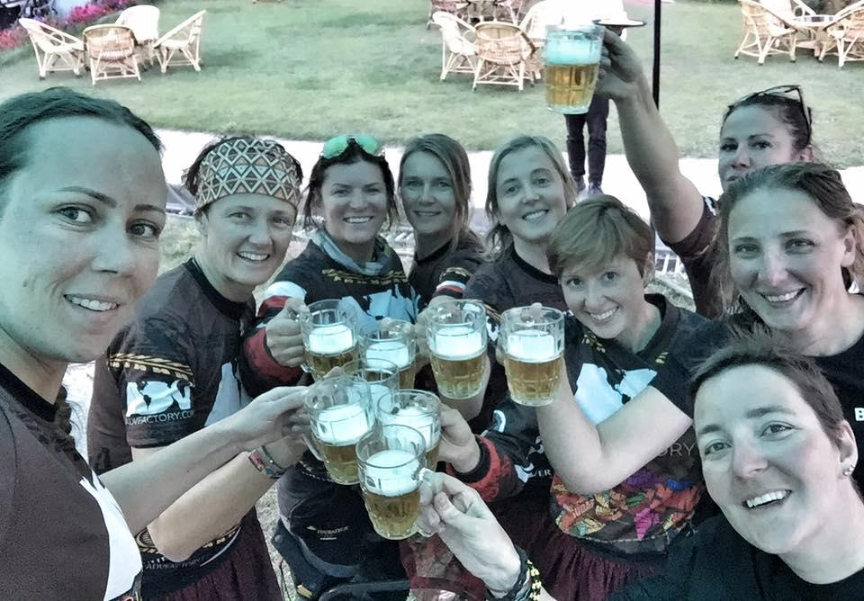

Zanskar&Ladakh Bike Tour15D/14N
Pack type | Cost | Cost Including | Cost Excluding
Pack A  For Bike Only | 71500 | Bike 500cc,  Twin sharing room ,  2 meals ,  Permit ILP ,  All toll and entry fee ,  Guide for Biking ,  Mechanical / Medical Backup with AMS Kit  Guide bag ( t shirt /sticker /map etc ) ,Luggage carrying Jeep ,  Video and Photos Shoot  Trip preparation details.  Day to Day Details Itinerary | Bike Damage /fine/ Insurance  Bike Fuel  Extra Stay  Extra meal / Drinks ( If any )  Extra luggage Jeep ( If any )
Pack B  For Biker and Jeep | 51500 | Twin sharing room ,  2 meals ,  Permit ILP ,  All toll and entry fee ,  Guide for biking ,  Mechanical / Medical Backup  Guide bag ( T- shirt /sticker /etc ) Luggage carrying Jeep,  Video and Photos Shoot,  Map with trip preparation details  Guidance for Bike Transport  Day to Day Details Itinerary | Bike / SUV Rent ( if any )  Bike / SUV Damage /fine/ Insurance  Bike /SUV Fuel  Extra Stay ( If any )  Extra Meal / Drinks ( If any )  Extra luggage Jeep ( If any)  Bike transport cost Extra
Pack C  For Bike and Jeep | 47500 | Room for 3 person Sharing ,  2 meals ,  Permit ILP ,  All toll and entry fee ,  Guide for Biking ,  Mechanical / Medical Backup  Guide bag ( T- shirt /sticker /etc ) Luggage carrying Jeep  Video and Photos Shoot  Map with trip preparation details  Guidance for Bike Transport  Day to Day Details Itinerary | Bike / SUV Rent ( if any )  Bike / SUV Damage /fine/ Insurance  Bike /SUV Fuel  Extra Stay ( If any )  Extra Meal / Drinks ( If any )  Extra luggage Jeep ( If any)  Bike transport cost Extra
Pack D  for Club Members only (* condition applied) | 12500 | Room 2/3 person Sharing (we Book You pay)  Meal ( Eat and pay) ,  Permit ILP ,  All toll and entry fee ,  Guide for Biking ,  Mechanical / Medical Backup  Guide bag ( T- shirt /sticker /etc ),  Video and Photos Shoot  Map with trip preparation details  Guidance for Bike Transport  Day 2 Day Details Itinerary | Bike / SUV Rent ( if any )  Bike / SUV Damage /fine/ Insurance  Bike /SUV Fuel  Stay cost we book for you you pay at place.  Meal / Drinks ( Eat & pay )  Cost for luggage Jeep ( if You want to carry )  Bike transport cost Extra
Pack E  For Share Cab / SUV /backup Vehicle | 68500 | Share SUV / MUV cab or Backup Car  Room 2 person Sharing ,  2 meal a day ,  Permit ILP ,  All toll and entry fee ,  Guide ,  Medical Backup with AMS kit,  Guide bag ( t shirt /sticker / map etc )  Video and Photos Shoot  Trip preparation details  Day 2 Day Details Itinerary | Extra Meal ( If any )

- Condition applied – For Details Call or whats app- Rahul-9896165335,9466175335

Including Cost
1. All 15Nights Accommodation on 2/3 sharing Basis at Nice & Clean tents/Hotels.( As Per pack )
2. Meal (Local best food as per available on BF and Dinner or as per pack )
3. Guidance to best places for Meals at Pay N Eat (Lunch & Dinner if any).
4. Backup Jeep full way
5. Experienced Guide full way
6. Inner line permits to restricted/protected areas.
7. Experienced mechanic with Spare Parts.
8. Experienced Doctor Medical backup with oxygen (O2) & AMS pack.
9. LWR T-Shirt for memories
10. LWR Stickers for your Jeep, motorcycle, helmet more.
11. All trip photos.
12. Things to carry list with Map.

Not in cost ;-
- Stay of extra days ( But we manage or book for you Before or after )
- Extra food Like Lunch/Dinner atCities (Like /Srinagar /Padum /Leh/Manali) where Person prefer different platters according to their personal taste. Pay & Eat (If any).
- Bike /Jeep/Cab rent ( if any )
- Fuel of vehicles.
- Any Damage/fine/ Insurance cost.
- Extra luggage care vehicle cost will Shared by group as per requirement.( If any )
- Any kind of personal expenses or optional tours, extra meals, starters (Alcoholic, Mineral, Soft Drinks, Aerated) etc.
- Extra guide fee, Camera & Video fee ,Tips, Insurance, Laundry, Phone
- Cost of plan and itinerary change because of Weather or Nature effects.

- Booking your plan with 25% of amount of total cost
- Balance 75% - 7 day before the trip
- As soon as you can we have only 15 seats..1st come 1st book
- Register here

Account name ;-Ladakh Way Round
Account no ;- 50200013560290
Account type ;- Current
RTGS/NEFT – IFSC code; - HDFC0003243
Bank Branch code; - 3243
Swift Code; - HDFCINBB
Branch; - HDFC bank , Ambala Road , Shahzadpur , Ambala , Haryana. India . 134202.
You can join us for fix tour of ;-

-------------------------------------------------------------------------------------
More Call/whatsapp;-
MAT :-9896165335,9466175335
RICKY;- 9781336000
info@planetwayround.com
www.planetwayround.com

Zanskar & Ladakh Bike & Jeep Tour

ZANSKAR LAND OF GLACIERS AND LAKES OF LADAKH

Our Zanskar Bike Tour is founded on our years of experience with motorcycle expeditions in Ladakh. You will experience new tracks, passes and highlights. Extreme Zanskar is very rarely covered and we are delighted to offer you extreme Zanskar bike tour. The off-roading to Ladakh, India’s coldest desert is a once-in-a-life time experience. Staying in tents, eating packed food and enjoying the surrounding environment can only be done in the region like Ladakh. This challenging tour demands solid riding skills, a sense of adventure and flexibility, which is very must require when taking part in Himalaya expeditions which covers around 2800 km and considerable altitude differences.

No of Trip Days | 15 days and 15 nights
Total Distance Covered | 2800km
Off-Roading Distance | 1800km
Best Time to visit | May to September
Staple Food | Dal, Rajma, Rice, Yak meat, Thupka, Momos,Noodles, Maggi,Yak cheese
Culture | Buddhism and Muslim
Number of Passes covered | 15 passes
Number of lakes covered | 5 lakes
Modes of Accessibility | Bike, Jeeps, XUV’s, Cycle, Trekking
Average Temperature | Day time : Average 25 degree Celsius  Night time : Average 5 to 10 degree Celsius
Hotel Stays | 10 days
Tent Stays | 5 days
Average Journey Hours per day | 6 to 8 Hrs.
Highlighted attraction of the Trip | Khardungla Pass, Zozila pass, Penzila, Changlangla, Pangong Lake, Drang-Drum Glacier, Tso Morari lake, White Dessert (Nubra Valley) , Gata Loops and many more. For Details refer Itinerary.
Hotel Stays | 10 days
Tent Stays | 5 days
Average Journey Hours per day | 6 to 8 Hrs.
Highlighted attraction of the Trip | Khardungla Pass, Zozila pass, Penzila, Changlangla, Pangong Lake, Drang-Drum Glacier, Tso Morari lake, White Dessert (Nubra Valley) , Gata Loops and many more. For Details refer Itinerary.
Hotel Stays | 10 days
Tent Stays | 5 days
Average Journey Hours per day | 6 to 8 Hrs.
Highlighted attraction of the Trip | Khardungla Pass, Zozila pass, Penzila, Changlangla, Pangong Lake, Drang-Drum Glacier, Tso Morari lake, White Dessert (Nubra Valley) , Gata Loops and many more. For Details refer Itinerary.
Hotel Stays | 10 days
Tent Stays | 5 days
Average Journey Hours per day | 6 to 8 Hrs.
Highlighted attraction of the Trip | Khardungla Pass, Zozila pass, Penzila, Changlangla, Pangong Lake, Drang-Drum Glacier, Tso Morari lake, White Dessert (Nubra Valley) , Gata Loops and many more. For Details refer Itinerary.
Hotel Stays | 10 days
Tent Stays | 5 days
Average Journey Hours per day | 6 to 8 Hrs.
Highlighted attraction of the Trip | Khardungla Pass, Zozila pass, Penzila, Changlangla, Pangong Lake, Drang-Drum Glacier, Tso Morari lake, White Dessert (Nubra Valley) , Gata Loops and many more. For Details refer Itinerary.
Hotel Stays | 10 days
Hotel Stays | 10 days
Tent Stays | 5 days
Average Journey Hours per day | 6 to 8 Hrs.
Highlighted attraction of the Trip | Khardungla Pass, Zozila pass, Penzila, Changlangla, Pangong Lake, Drang-Drum Glacier, Tso Morari lake, White Dessert (Nubra Valley) , Gata Loops and many more. For Details refer Itinerary.
Hotel Stays | 10 days
Tent Stays | 5 days
Average Journey Hours per day | 6 to 8 Hrs.
Highlighted attraction of the Trip | Khardungla Pass, Zozila pass, Penzila, Changlangla, Pangong Lake, Drang-Drum Glacier, Tso Morari lake, White Dessert (Nubra Valley) , Gata Loops and many more. For Details refer Itinerary.
Hotel Stays | 10 days
Tent Stays | 5 days
Average Journey Hours per day | 6 to 8 Hrs.
Highlighted attraction of the Trip | Khardungla Pass, Zozila pass, Penzila, Changlangla, Pangong Lake, Drang-Drum Glacier, Tso Morari lake, White Dessert (Nubra Valley) , Gata Loops and many more. For Details refer Itinerary.
Hotel Stays | 10 days
Tent Stays | 5 days
Average Journey Hours per day | 6 to 8 Hrs.
Highlighted attraction of the Trip | Khardungla Pass, Zozila pass, Penzila, Changlangla, Pangong Lake, Drang-Drum Glacier, Tso Morari lake, White Dessert (Nubra Valley) , Gata Loops and many more. For Details refer Itinerary.
Hotel Stays | 10 days
Tent Stays | 5 days
Average Journey Hours per day | 6 to 8 Hrs.
Highlighted attraction of the Trip | Khardungla Pass, Zozila pass, Penzila, Changlangla, Pangong Lake, Drang-Drum Glacier, Tso Morari lake, White Dessert (Nubra Valley) , Gata Loops and many more. For Details refer Itinerary.
Hotel Stays | 10 days
Tent Stays | 5 days
Average Journey Hours per day | 6 to 8 Hrs.
Highlighted attraction of the Trip | Khardungla Pass, Zozila pass, Penzila, Changlangla, Pangong Lake, Drang-Drum Glacier, Tso Morari lake, White Dessert (Nubra Valley) , Gata Loops and many more. For Details refer Itinerary.
Hotel Stays | 10 days
Tent Stays | 5 days
Average Journey Hours per day | 6 to 8 Hrs.
Highlighted attraction of the Trip | Khardungla Pass, Zozila pass, Penzila, Changlangla, Pangong Lake, Drang-Drum Glacier, Tso Morari lake, White Dessert (Nubra Valley) , Gata Loops and many more. For Details refer Itinerary.
Hotel Stays | 10 days
Tent Stays | 5 days
Average Journey Hours per day | 6 to 8 Hrs.
Highlighted attraction of the Trip | Khardungla Pass, Zozila pass, Penzila, Changlangla, Pangong Lake, Drang-Drum Glacier, Tso Morari lake, White Dessert (Nubra Valley) , Gata Loops and many more. For Details refer Itinerary.
Hotel Stays | 10 days
Tent Stays | 5 days
Average Journey Hours per day | 6 to 8 Hrs.
Highlighted attraction of the Trip | Khardungla Pass, Zozila pass, Penzila, Changlangla, Pangong Lake, Drang-Drum Glacier, Tso Morari lake, White Dessert (Nubra Valley) , Gata Loops and many more. For Details refer Itinerary.
Hotel Stays | 10 days
Tent Stays | 5 days
Average Journey Hours per day | 6 to 8 Hrs.
Highlighted attraction of the Trip | Khardungla Pass, Zozila pass, Penzila, Changlangla, Pangong Lake, Drang-Drum Glacier, Tso Morari lake, White Dessert (Nubra Valley) , Gata Loops and many more. For Details refer Itinerary.
Hotel Stays | 10 days
Tent Stays | 5 days
Average Journey Hours per day | 6 to 8 Hrs.
Highlighted attraction of the Trip | Khardungla Pass, Zozila pass, Penzila, Changlangla, Pangong Lake, Drang-Drum Glacier, Tso Morari lake, White Dessert (Nubra Valley) , Gata Loops and many more. For Details refer Itinerary.
Hotel Stays | 10 days
Tent Stays | 5 days
Average Journey Hours per day | 6 to 8 Hrs.
Highlighted attraction of the Trip | Khardungla Pass, Zozila pass, Penzila, Changlangla, Pangong Lake, Drang-Drum Glacier, Tso Morari lake, White Dessert (Nubra Valley) , Gata Loops and many more. For Details refer Itinerary.
Hotel Stays | 10 days
Tent Stays | 5 days
Average Journey Hours per day | 6 to 8 Hrs.
Highlighted attraction of the Trip | Khardungla Pass, Zozila pass, Penzila, Changlangla, Pangong Lake, Drang-Drum Glacier, Tso Morari lake, White Dessert (Nubra Valley) , Gata Loops and many more. For Details refer Itinerary.
Hotel Stays | 10 days
Tent Stays | 5 days
Average Journey Hours per day | 6 to 8 Hrs.
Highlighted attraction of the Trip | Khardungla Pass, Zozila pass, Penzila, Changlangla, Pangong Lake, Drang-Drum Glacier, Tso Morari lake, White Dessert (Nubra Valley) , Gata Loops and many more. For Details refer Itinerary.
Hotel Stays | 10 days
Tent Stays | 5 days
Average Journey Hours per day | 6 to 8 Hrs.
Highlighted attraction of the Trip | Khardungla Pass, Zozila pass, Penzila, Changlangla, Pangong Lake, Drang-Drum Glacier, Tso Morari lake, White Dessert (Nubra Valley) , Gata Loops and many more. For Details refer Itinerary.
Hotel Stays | 10 days
Tent Stays | 5 days
Average Journey Hours per day | 6 to 8 Hrs.
Highlighted attraction of the Trip | Khardungla Pass, Zozila pass, Penzila, Changlangla, Pangong Lake, Drang-Drum Glacier, Tso Morari lake, White Dessert (Nubra Valley) , Gata Loops and many more. For Details refer Itinerary.
Hotel Stays | 10 days
Tent Stays | 5 days
Average Journey Hours per day | 6 to 8 Hrs.
Highlighted attraction of the Trip | Khardungla Pass, Zozila pass, Penzila, Changlangla, Pangong Lake, Drang-Drum Glacier, Tso Morari lake, White Dessert (Nubra Valley) , Gata Loops and many more. For Details refer Itinerary.
Hotel Stays | 10 days
Tent Stays | 5 days
Average Journey Hours per day | 6 to 8 Hrs.
Highlighted attraction of the Trip | Khardungla Pass, Zozila pass, Penzila, Changlangla, Pangong Lake, Drang-Drum Glacier, Tso Morari lake, White Dessert (Nubra Valley) , Gata Loops and many more. For Details refer Itinerary.
Hotel Stays | 10 days
Tent Stays | 5 days
Average Journey Hours per day | 6 to 8 Hrs.
Highlighted attraction of the Trip | Khardungla Pass, Zozila pass, Penzila, Changlangla, Pangong Lake, Drang-Drum Glacier, Tso Morari lake, White Dessert (Nubra Valley) , Gata Loops and many more. For Details refer Itinerary.
Hotel Stays | 10 days
Tent Stays | 5 days
Average Journey Hours per day | 6 to 8 Hrs.
Highlighted attraction of the Trip | Khardungla Pass, Zozila pass, Penzila, Changlangla, Pangong Lake, Drang-Drum Glacier, Tso Morari lake, White Dessert (Nubra Valley) , Gata Loops and many more. For Details refer Itinerary.
Hotel Stays | 10 days
Tent Stays | 5 days
Average Journey Hours per day | 6 to 8 Hrs.
Highlighted attraction of the Trip | Khardungla Pass, Zozila pass, Penzila, Changlangla, Pangong Lake, Drang-Drum Glacier, Tso Morari lake, White Dessert (Nubra Valley) , Gata Loops and many more. For Details refer Itinerary.
Hotel Stays | 10 days
Tent Stays | 5 days
Average Journey Hours per day | 6 to 8 Hrs.
Highlighted attraction of the Trip | Khardungla Pass, Zozila pass, Penzila, Changlangla, Pangong Lake, Drang-Drum Glacier, Tso Morari lake, White Dessert (Nubra Valley) , Gata Loops and many more. For Details refer Itinerary.
Hotel Stays | 10 days
Tent Stays | 5 days
Average Journey Hours per day | 6 to 8 Hrs.
Highlighted attraction of the Trip | Khardungla Pass, Zozila pass, Penzila, Changlangla, Pangong Lake, Drang-Drum Glacier, Tso Morari lake, White Dessert (Nubra Valley) , Gata Loops and many more. For Details refer Itinerary.
Hotel Stays | 10 days
Tent Stays | 5 days
Average Journey Hours per day | 6 to 8 Hrs.
Highlighted attraction of the Trip | Khardungla Pass, Zozila pass, Penzila, Changlangla, Pangong Lake, Drang-Drum Glacier, Tso Morari lake, White Dessert (Nubra Valley) , Gata Loops and many more. For Details refer Itinerary.
Hotel Stays | 10 days
Tent Stays | 5 days
Average Journey Hours per day | 6 to 8 Hrs.
Highlighted attraction of the Trip | Khardungla Pass, Zozila pass, Penzila, Changlangla, Pangong Lake, Drang-Drum Glacier, Tso Morari lake, White Dessert (Nubra Valley) , Gata Loops and many more. For Details refer Itinerary.
Hotel Stays | 10 days
Tent Stays | 5 days
Average Journey Hours per day | 6 to 8 Hrs.
Highlighted attraction of the Trip | Khardungla Pass, Zozila pass, Penzila, Changlangla, Pangong Lake, Drang-Drum Glacier, Tso Morari lake, White Dessert (Nubra Valley) , Gata Loops and many more. For Details refer Itinerary.

